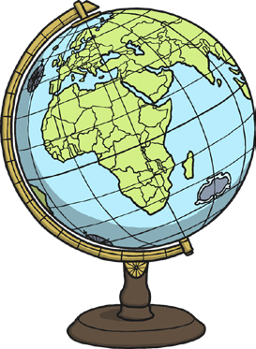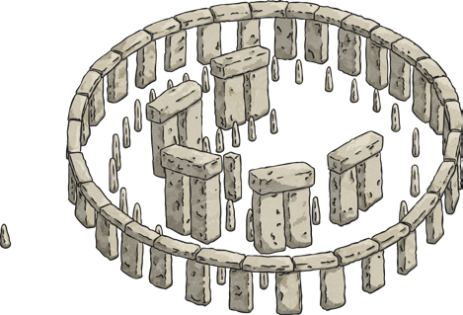

|  |  |
| --- | --- |
| **Key Vocabulary** | |
| **continent** | A very large area of land that includes all the islands with it. |
| **ocean** | A large area of sea. |
| **population** | The number of people that live in a particular place. |
| **landmark** | A well-known building or place. |
| **Australasia** | The continent of Australasia is often referred to as just Australia. It has about 28 countries and island groups. |
| **desert** | A large area of land that has very little rainfall and where not much grows. |
| **rainforest** | A large area of land with lots of tall trees and plenty of rainfall. |

|  |
| --- |
| **Continents** |
| There are seven **continents**: Africa, Antarctica, Asia, **Australasia**, Europe, North America and South America. Some **continents** have many countries, others do not. |

|  |
| --- |
| **World Oceans** |
| There are five **oceans** in the world:  the Arctic Ocean, the Atlantic Ocean, the Indian Ocean,  the Pacific Ocean and the Southern Ocean. |

|  |  |  |
| --- | --- | --- |
| **Europe** | **Landmarks** | **Continent Facts** |
| Europe is the second smallest **continent**. It has around 44 countries, including England. About 740 million people live in Europe. It is the third largest **continent** in terms of **population**. | Europe has many famous **landmarks**, including Stonehenge in England, the Matterhorn in Switzerland and the Eiffel Tower  in France.  **Landmarks** in other **continents** include the Yangtze River in China (which is in Asia) and the Great Barrier  Reef located off the coast of Australia. | Half the world’s **population**  live in Asia.  The largest **desert** in the world (the Sahara) is in Africa.  North America is twice the size of Europe.  Over half of Australia is **desert**  or receives little rain.  The Amazon **rainforest** is in South America.  Antarctica is known as the ‘frozen continent.’ |

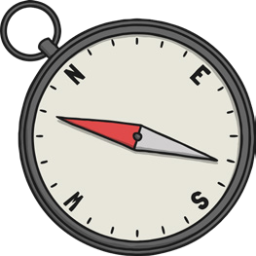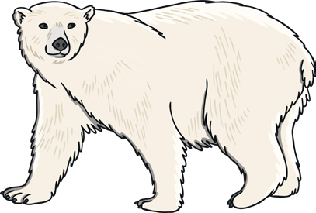

|  |  |
| --- | --- |
| **Key Vocabulary** | |
| **compass** | A piece of equipment that tells you what direction you are travelling in. The main compass points are north, south, east and west. |
| **climate** | The usual weather conditions of an area. |
| **equator** | An imaginary line drawn around the middle of Earth, dividing it into the Northern and Southern Hemispheres. |
| **tropical** | Hot and humid. |
| **temperate** | Mild weather. Neither very hot nor very cold. |
| **capital city** | An important city, often where the government works. |
| **currency** | The money used in a country. |
| **cuisine** | Traditional food of a country. |
| **aerial** | Seen from above. |

|  |
| --- |
| **Climate** |
| Countries around the world have different **climates**. **Climates** can be sorted into the following zones: warm, cold (or polar), **tropical** and **temperate**. Countries near the equator tend to have a hotter **climate**. Different animals are better suited to living in countries with a particular **climate**. |

|  |
| --- |
| **Planning a Journey** |
| When people plan a journey, they might use maps and a **compass** to help them. You can record a journey on a map using a journey line. |

|  |  |  |
| --- | --- | --- |
| **Europe** | **Landmarks** | **Continent Facts** |
| France is in Europe. Its  **capital city** is Paris.  The **currency** of France is the euro and the national language is French. The **climate** in France is mostly **temperate**.  Visitors to France can enjoy the French **cuisine**, such as croissants and landmarks like the Arc De Triomphe. | We can look at **aerial** photos of places and see different features.  Some of these are made (or changed) by humans, others are natural (made by nature). | Natural features include caves, rocks, cliffs, forests and mountains. Natural features are sometimes called ‘physical features.’  Features made by people include bridges, buildings and roads.  These features are sometimes called ‘human features.’ |